

**High Level Design**

**Final Project Title: Project X – QR -Based Attendance System**

**Prepared by: Team BAMP**

Sophie A. Bohol

Cloe Den Mabanding

Maureen Portillo

Jhomarie Avenido

May 26, 2025

# Overview

Project X is a mobile-based attendance system that utilizes QR code scanning to enable secure, efficient, and real-time attendance tracking. It supports three user roles: Administrator, Instructor, and Student. The system provides QR generation, student checkin, schedule management, and attendance reporting through a modern mobile app.

# Target Users

**Administrator:** Manages users and course assignments.

**Instructor:** Generates class QR codes and monitors attendance logs.

**Student:** Logs their presence by scanning QR codes generated per session.

# Key Modules

**Authentication:** Login system with role-based access.

**User Management:** Admins can manage user accounts and roles.

**Course Management:** Admins can manage course details and enrolled students.

**QR Code Generation:** Instructors can generate session-specific QR codes.

**Attendance Scanning:** Students scan QR codes to log attendance.

**Logging & Reporting:** All actions are logged for auditing, and attendance reports can be generated.

# Technology Stack

|  |  |
| --- | --- |
| **Layer** | **Technology** |
| Frontend | React Native, Expo |
| Backend | Node.js, Express |
| Database | MongoDB Atlas |

# System Architecture Diagram

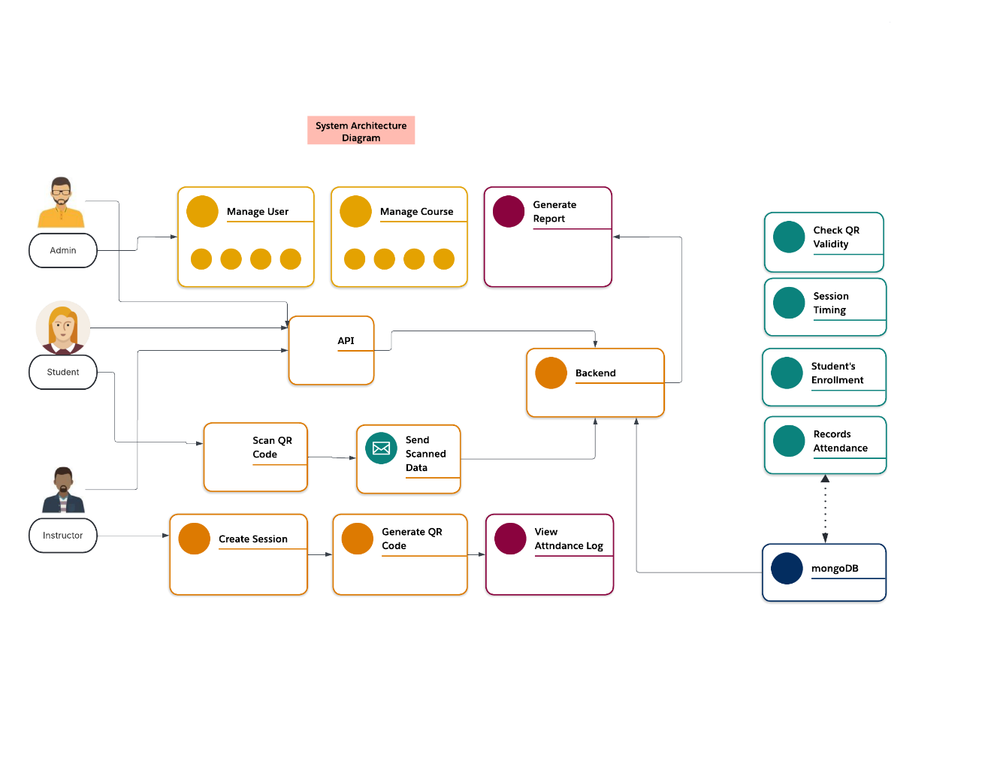

## Use Case Diagram

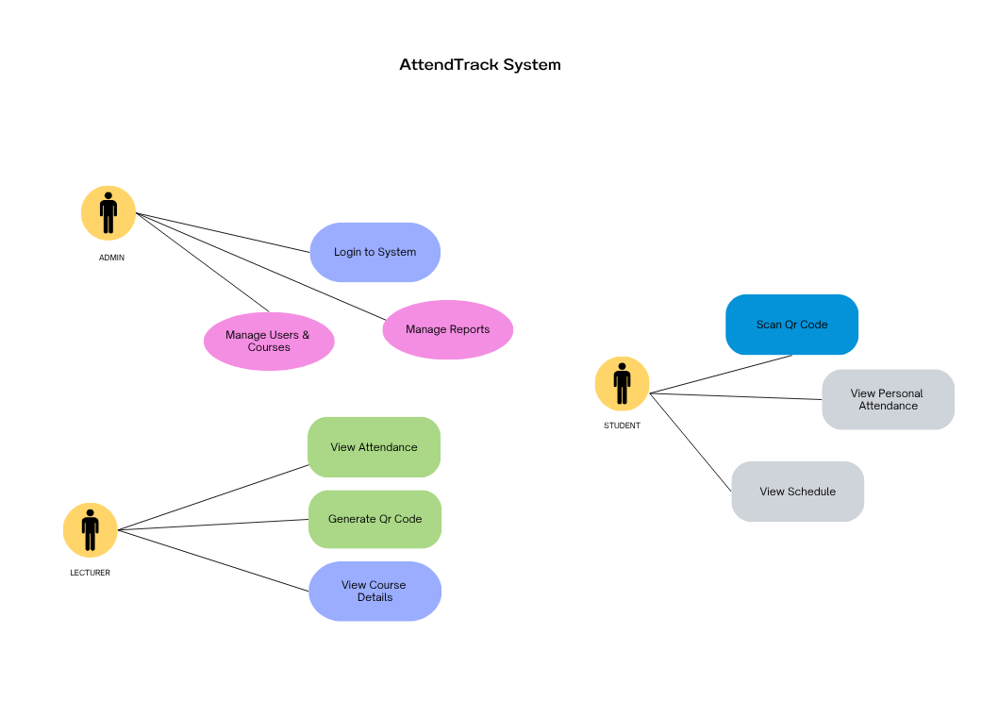

## Class Diagram

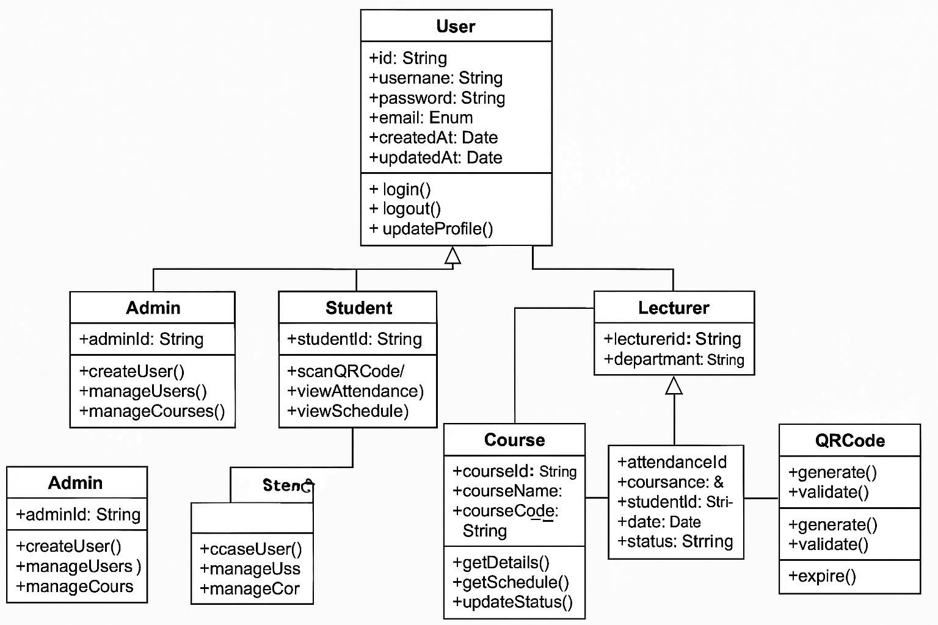

# Database Collections

**Users Collection:**

{

_id: ObjectId, username: String, password: String (hashed), email: String, role: String, created_at: Date

}

**Courses Collection:**

{

_id: ObjectId, name: String, code: String, lecturer_id: ObjectId, schedule: String, created_at: Date

}

**Attendance Collection:**

{

_id: ObjectId, course_id: ObjectId, student_id: ObjectId, date: Date, status: String, qr_code_id: ObjectId

}

**QRCodes Collection:**

{

_id: ObjectId, course_id: ObjectId, generated_at: Date, expires_at: Date, is_active: Boolean

}

**7. Security Considerations**

**- Authentication:** JWT-based authentication

# - Password Security: Bcrypt hashing

* **API Security:** Rate limiting, input validation
* **QR Code Security:** Time-based expiration
* **Data Protection:** Input sanitization, XSS prevention **Key Relationships and Features:**

# User (Base Class)

Abstract base class for all users

Common attributes: id, username, password, email

Basic authentication methods

# Admin (Inherits User)

Manages users and courses

Full system access

Administrative functions

# Lecturer (Inherits User)

Views assigned courses

Generates QR codes

Views attendance reports

Student (Inherits User)

Scans QR codes

Views personal attendance

Views course schedule

# Course

Contains course details

Linked to Lecturer

Has many Students

Has many Attendance records

# Attendance

Records student attendance

Links Student, Course, and QR Code

Tracks attendance status

# QRCode

Generated for attendance marking

Time-based expiration Linked to Course and Attendance

**Relationships:**

User ─┬─► Admin

├─► Lecturer

└─► Student

**Lecturer** ─── **1:N** ───**> Course**

**Course** ──── **1:N** ───**> QRCode**

**Course** ──── **1:N** ───**> Attendance**

**Student** ─── **1:N** ───**> Attendance**

# QRCode ──── 1:1 ───> Attendance

**Conclusion:**

Project X, or the AttendTrack System, is built to make attendance tracking faster, easier, and more secure. Designed for Admins, Lecturers, and Students, the system uses QR code scanning to log attendance in real-time through a mobile app.

With a clean architecture powered by React Native, Node.js, and MongoDB Atlas, each user role has access to exactly what they need—whether it's managing users, generating QR codes, or viewing schedules and attendance logs.

Security is built-in from the start with JWT authentication, hashed passwords, and timelimited QR codes, ensuring data is safe and access is controlled.

At its heart, AttendTrack simplifies a routine task and brings convenience to schools and training environments—no more manual logs or roll calls, just scan and go.

It's not just efficient—it’s designed to work smoothly for real people, every day.